Paper template for

Green Hydrogen Patents: Prior Art Review and Recommendations
for New Patents
First Authorª, Second Author^{b}, Third Author^{a,b,}1
aFirst affiliation, Address, City and Postcode, Country
bSecond affiliation, Address, City and Postcode, Country

Abstract
The abstract should be a summary, typically around 150-250 words. It should provide a clear and concise overview of the patent. Explain its purpose or the problem it addresses. Be straightforward in conveying the core idea. Ensure that the abstract is clear, concise, and accurate. It should effectively convey the essence of the patent without ambiguity.
[copyright information to be updated in production process]
Keywords: Type your keywords here, separated by semicolons [maximum of 5];
1. Introduction
❖ Begin your introduction with an attention-grabbing statement or question related to the patent you're
reviewing. This can pique the reader's interest.
❖ Offer background information on the patent, its inventor, and the significance of the invention. Explain
why this patent is worthy of review.
❖ Indicate whether your review covers a specific aspect of the patent, such as its technical details, legal
implications, or its impact on a particular industry.
2. Background with consideration of prior art.
❖ Provide a brief historical context by discussing the development and evolution of the technology or field.
Mention key milestones and breakthroughs.
❖ Introduce the concept of prior art. This includes existing technologies, methods, or solutions that have
been used to address the problem before the patent in question.
❖ Begin by defining the problem or need that the patent in question addresses. Explain the specific challenges
or shortcomings within the relevant industry or field.
❖ Describe the existing patent landscape related to the problem or technology. Highlight any significant
patents that are relevant to the subject matter of the review.

* Corresponding author. Tel.: +0-000-000-0000 ; fax: +0-000-000-0000 .
E-mail address: author@institute.xxx




3. Detail discussion of prior art of patent family.
❖ Begin by introducing the concept of prior art in the context of the patent family you are reviewing. Explain
that prior art encompasses all existing technologies, methods, or solutions relevant to the patent family's
subject matter.
❖ Categorize the prior art into different types, such as patents, products, or other relevant sources. Provide a
brief overview of each type.

4. Importance of such patent family in the industry.
❖ Start by providing context about the industry the patent family pertains to. Describe its size, significance,
and key players. Discuss the industry's current state and any notable trends or challenges.
❖ Identify and describe the specific problems or challenges faced by the industry that the patent family can
potentially address or alleviate.
❖ Identify and describe the specific problems or challenges faced by the industry that the patent family can
potentially address or alleviate.

5. Economic important and feasibility value and for Oman.
❖ Assess the patent family's market potential. Discuss its ability to meet market demands, create new
opportunities, and contribute to the industry's growth.
❖ Discuss how the patent family can contribute to revenue generation through licensing, product sales, or
strategic partnerships.
❖ Assess the technical viability of implementing the patent family's technology within Oman. Consider the
country's technological infrastructure and readiness for innovation.

6. Potential importance into patent family.
❖ Start by defining what a patent family is. Explain that it consists of a group of patents related to the same
invention or innovation, filed in various countries, and sharing a common priority claim.
❖ Emphasize that a patent family provides global protection for the underlying invention. It extends legal
coverage beyond a single country to multiple jurisdictions.

7. Future Scope for the present patent family.
❖ Acknowledge potential challenges and risks that could impact the future scope. Discuss how these
challenges can be addressed or mitigated.
❖ Discuss the strategic roadmap for the patent family. Explain how the patent holders plan to navigate the
evolving landscape and seize future opportunities.
❖ Conclude by summarizing the potential future scope of the patent family. Provide recommendations or
insights on how to maximize its impact and relevance in the years ahead.

Tables
An illustrative example is provided below for the author’s reference.
Table 1. An example of a table.

An example of a column heading Column A (t) Column B (t)
And an entry 1 2
And another entry 3 4
And another entry 5 6

Figures
The figure number and caption should be typed below the illustration in 8 pt and left justified [Note: one-line captions of length less than column width (or full typesetting width or oblong) centered]. Artwork has no text along the side of it in the main body of the text. However, if two images fit next to each other, these may be placed next to each other to save space. For example, see Fig. 1.
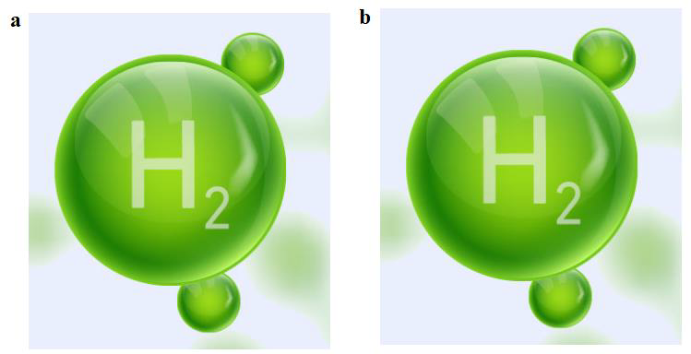

Fig. 1. (a) first picture; (b) second picture.

References
References should be formatted in a numbered reference style, and listed in the order in which they
appeared in the artciel text.
N.B. Please include Patent numbers and DOIs for all journal articles.

Patent Reference format:
Inventor names are listed in inverted form with periods and spaces with an ampersand before final author's name.
Surname, First Initial. Middle Initial., qualifier if applicable.
Section 9.8 Format of the Author Element for more information
General Format:
Inventor1, Inventor2, et al. (Year Patent Issued). Title of patent (U.S. Patent No. (number retains commas)) U.S. Patent and Trademark Office. URL

Example:
Christiansen, G. K. (1971). Toy Building Set (U.S. Patent No. 3,597,875). U.S. Patent and Trademark Office. https://patft.uspto.gov/netacgi/nph-Parser?Sect1=PTO1&Sect2=HITOFF&d=PALL&p=1&u=%2Fnetahtml%2FPTO%2Fsrchnum.htm&r=1&f=G&l=50&s1=3597875.PN.&OS=PN/3597875&RS=PN/3597875

Journal and Book articles Reference format:
[1] Van der Geer J, Hanraads JAJ, Lupton RA. The art of writing a scientific article. J Sci Commun 2000; 163:51-9.
[2] Strunk Jr W, White EB. The elements of style. 3rd ed. New York: Macmillan; 1979.
[3] Mettam GR, Adams LB. How to prepare an electronic version of your article. In: Jones BS, Smith RZ, editors. Introduction to the electronic age, New York: E-Publishing Inc; 1999, p. 281-304.

